S60 print firmware upgrade instructions

1、First copy the firmware and apk to pda, then install update.apk

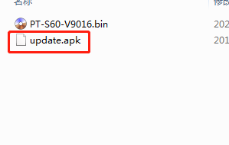

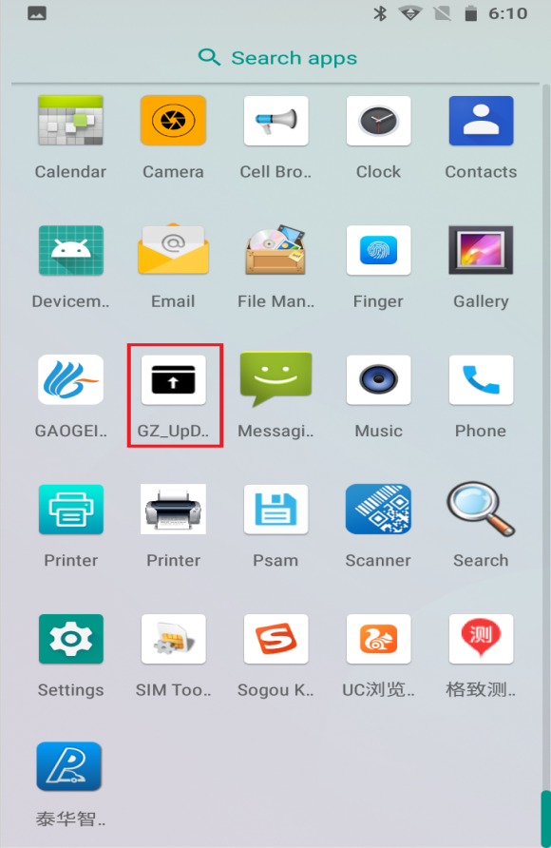

2、Select import file

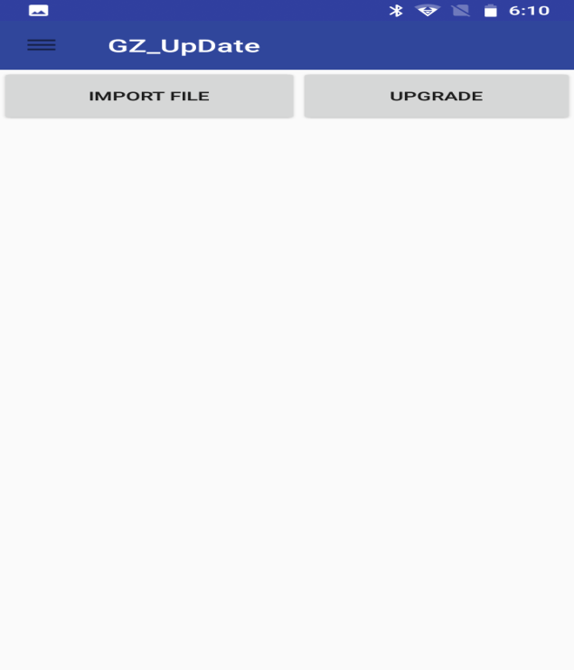

3、Show hide internal storage

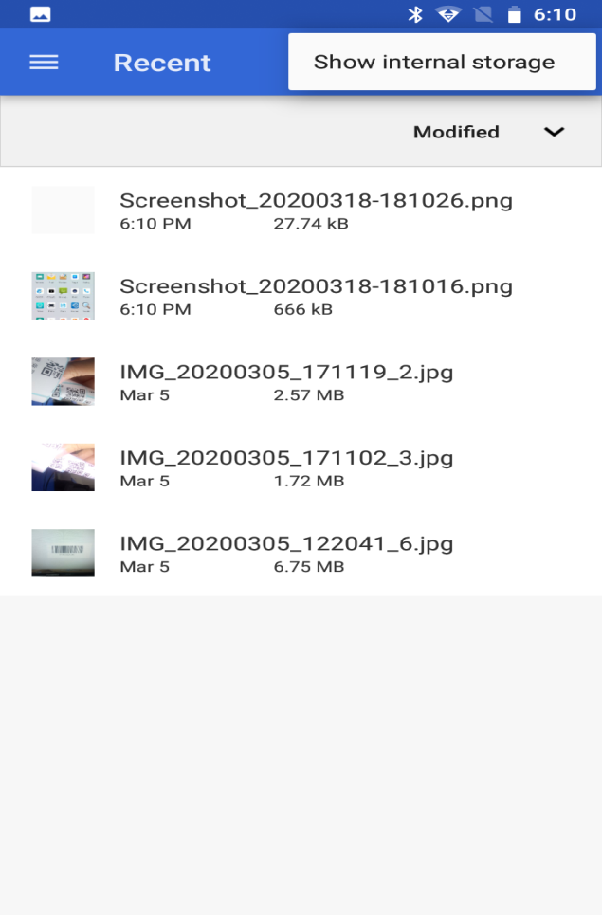

4、Select upgraded firmware file

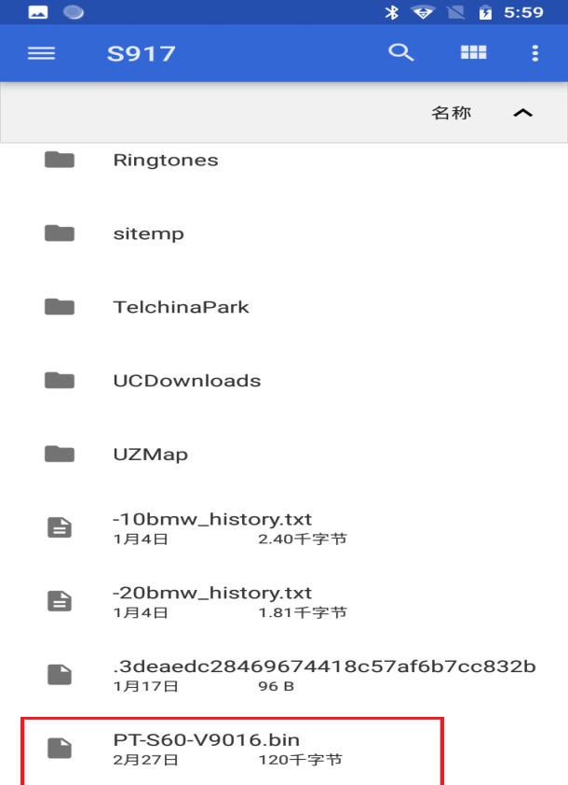

5、Wait for the upgrade to complete and restart the device.